User Guide: SafeTEEN – Mobile VR

Introduction
This guide provides instructions for using gaze-based interaction on mobile virtual reality (VR) devices. Gaze interaction allows players to navigate, select, and interact with in-game elements using only their line of sight, providing an intuitive and hands-free VR experience.

Understanding Gaze Interaction
- What is gaze interaction?
Instead of using controllers or touch input, the game uses gaze interaction powered by the mobile device’s gyroscope, enabling you to control gameplay by focusing your view on objects on the screen.
- How it works?
A blue dot will appear on gaze-interactable objects when you focus your sight on them.
- Tips for accuracy:
  - Keep your head steady.
  - Avoid rapid movements that might misalign your gaze.

System Requirements
- Mobile Device: Android/iOS
- VR Headset: cardboard 3D VR headset
- Additional Requirements: internet connection

Getting Started
- Enter the game and chose the scenario you want to play.
- Insert your mobile device into a cardboard 3D VR headset
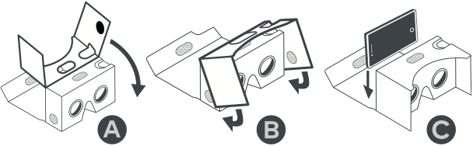
- Adjust headset alignment for a comfortable fit and clear view. Make sure the volume is right.

VR Game instructions
- When entering a scenario, turn your head left or right to locate the play button. When your gaze is on the correct spot, a blue dot will appear. Place the dot over the button, and a blue circle will form around it, indicating that your selection is loading. Wait until the outer circle is fully completed.
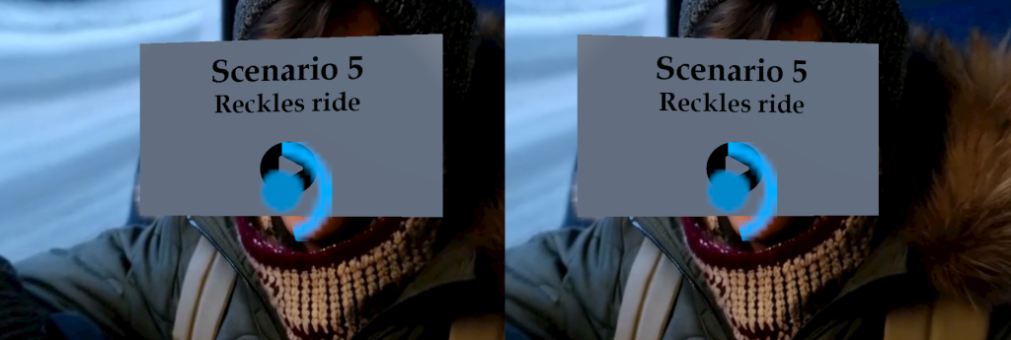
- The game combines narration with 180-degree videos to drive the storytelling. At the end of each video, two choices will appear on the screen in the form of buttons.
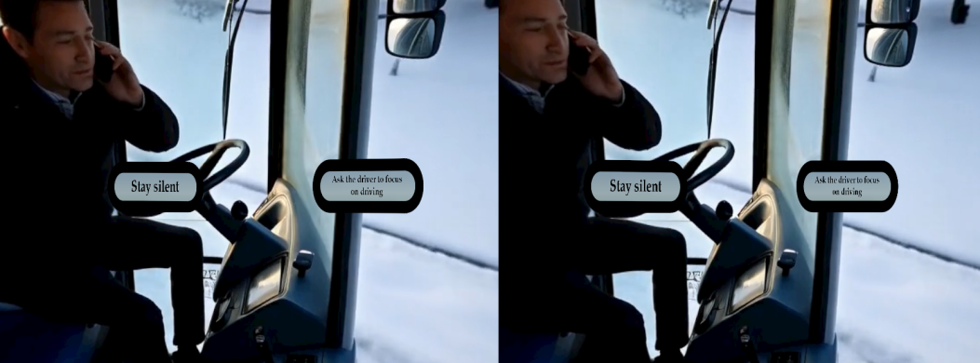
Listen carefully, and feel free to turn your head left and right to follow the story. To make a choice, simply focus your gaze on the button you want until the blue dot appears. Wait for the outer circle to complete. If you change your mind, simply move your gaze away from the selected button before the outer circle is completed.
- When the scenario is completed, you can return to the main menu page by using your phone’s buttons, where you can choose a new scenario to play.

Warning
If you feel dizzy or experience any discomfort during the VR experience, please remove the headset immediately!

User Guide: SafeTEEN – 2D Game

Introduction
This guide provides instructions for playing a 2D browser-based game that requires only a mouse and an internet connection. The game is designed for intuitive point-and-click interaction, allowing players to navigate, select, and interact with game elements easily.
System Requirements
- Device: Desktop or laptop computer
- Operating System: Windows, macOS, or Linux
- Browser: Any
- Internet Connection: Stable connection for smooth gameplay

Getting Started
- Open your preferred web browser.
- Navigate to the webpage and choose a scenario.
- Ensure your mouse is connected and functioning properly.
- Wait for the game to load fully before starting.
VR Game instructions
  - When entering a scenario click on the play button to start the story.

  - Make sure the volume is set correctly and that you have a clear view to follow the story. If the videos are slow, frozen, or the sound cuts out, check your internet connection.
  - At the end of the video, two choices will appear as buttons. Click on the one you want to select.
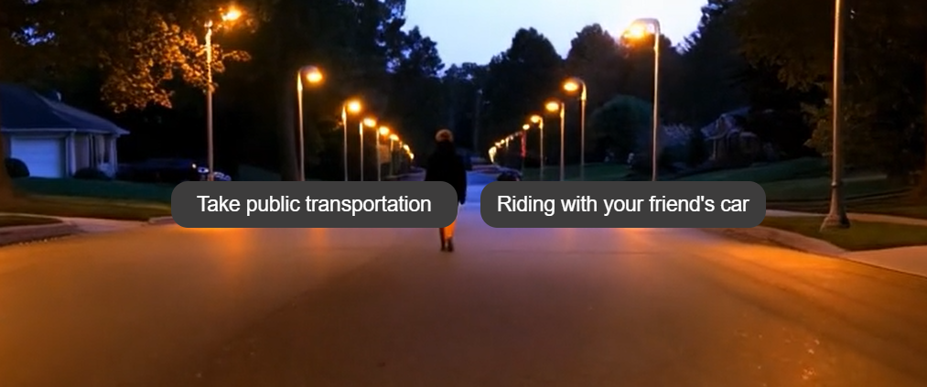
  - When the scenario is completed, you can return to the menu page by clicking 2 times on the previous button on your browser screen.

